GROUNDBREAKING PRODUCT RELEASE:
FORM & FUNCTION MEET – f-stop NEW MOUNTAIN SERIES CAMERA BACKPACKS
The all-new f-stop Mountain Series Camera Backpacks protect your equipment from the elements better than ever. And they look amazing doing it.

FOR IMMEDIATE RELEASE
St. Louis, Nov. 1, 2021 /PRNewswire/ - f-stop, the world's leading camera bag and accessory company, is announcing three newly designed camera bags as a part of their iconic Mountain Series: The SHINN 80L DuraDiamond™, TILOPA 50L DuraDiamond™, and AJNA 37L DuraDiamond™. Made with f-stop’s exclusive and proprietary DuraDiamond™ fabric, the new packs bring greater durability, more protection from the elements, and better organization features than ever before.

“These new camera packs are the result of hundreds of conversations with our customers and ambassadors. We listened and embarked upon a rigorous product development project, including dozens of field tests, interviews, and a lot of great feedback from the adventure and outdoor photography community. We’re so proud to share three extraordinary new camera backpacks that incorporate the industry’s best technology, materials and manufacturing processes,” said Druid Orion, f-stop CEO.

I’ve been traveling with an f-stop bag on my back in the mountains for the past 15 years. You can’t catch me anywhere without a camera nearby and I’m psyched to have the team at f-stop behind me.
- Tim Kemple, Founder Camp4 Collective
f-stop customers have an adventurous mindset. Whether that takes them to the far reaches of the globe or on adventures closer to home, f-stop camera bags are there to comfortably carry their equipment and protect it from the environment. f-stop bags have always been renowned for their quality, attention to detail, and rugged durability. The newly re-designed bags, build on the already impressive Mountain Series packs, raise the bar even higher.
There are several important upgrades in the new bags, but a few highlights include:

- New Fabric: DuraDiamond™ a proprietary fabric available exclusively on f-stop camera bags. It’s lighter, more weather resistant and stronger.

- Improved Weather Resistance: Welding in key areas combined with DuraDiamond™ material and weather resistant zippers offering even better protection from the elements.

- Improved Functionality: Enhanced organizational features include a back panel with magnetic closures for memory cards and additional zipper pouches for ease of access to key components such as batteries and cables and dedicated laptop sleeve in the TILOPA and SHINN.

- Stunning Aesthetics: Two new colors for the TILOPA and AJNA - Cypress and Magma. Plus, much of the hardware has been upgraded to T6 aluminum.

There is a limited quantity of each of the new bags available for immediate delivery. The SHINN Anthracite, and the TILOPA and AJNA in Cypress and Magma available for immediate delivery. TILOPA and AJNA Anthracite are available February 2022.

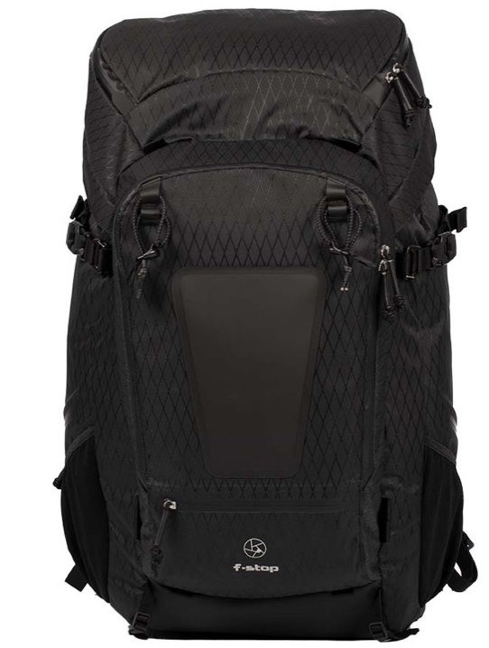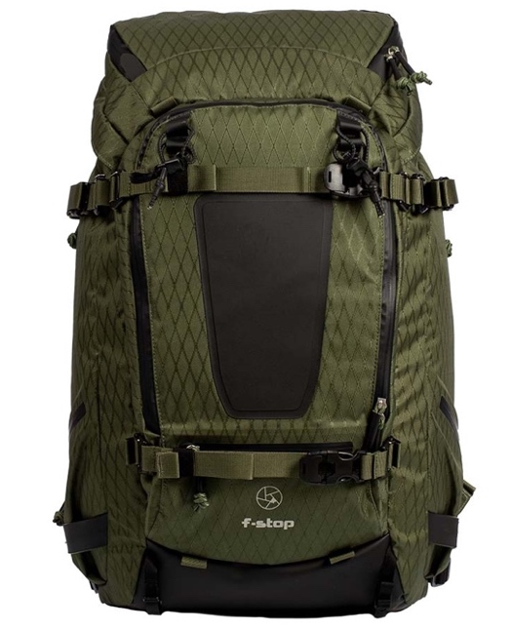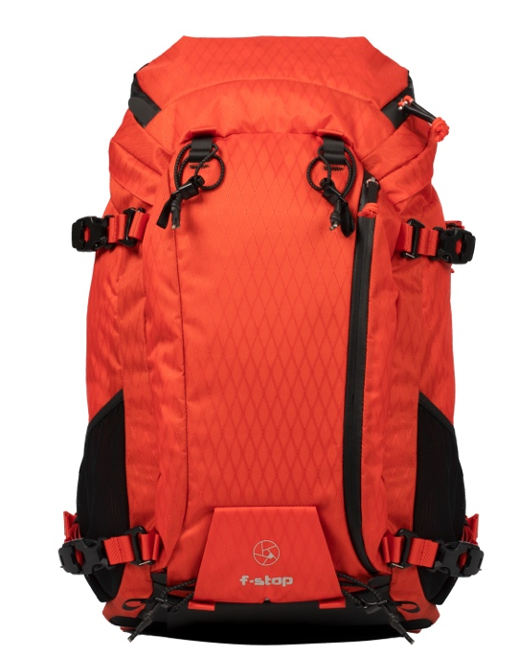
TILOPA 50L DuraDiamond™
Available in Cypress (shown) and Magma. Anthracite Available February 2022

SHINN 80L DuraDiamond™
Available in Anthracite
AJNA 37L DuraDiamond™
Available in Magma (shown) and Cypress. Anthracite Available February 2022

About f-stop
We believe your camera pack should empower you to capture the perfect shot, that’s why f-stop bags are engineered to get your gear safely and comfortably to any destination. From the beginning, f-stop has focused on empowering the world’s best visual creatives to access and capture their best images in remote locations around the world.


f-stop Gear @fstopgear @fstopgear

Name of Press Contact:
Chris Osborn. Marketing Director, f-stop
Phone: 314-566-9855
Email: chris@fstopgear.com

